Testing the Power Distribution Board

Servicing a SuperDARN Transceiver  
Step 4

Content

1. Introduction 3

2. Instructions 3

3. Conclusion 5

# Introduction

This document provides work instructions for testing the Power Distribution Board in a SuperDARN transceiver box. Before attempting to implement these instructions, be sure to complete all the preceding steps in the procedure for Servicing a SuperDARN Transceiver.

# Instructions

Following are the step-by-step instructions for testing the Power Distribution Board. In the case of unforeseen problems occurring, apply electronic fault-finding techniques. Refer to *Figure 2* for component and connection locations.

1. Connect the Phoenix connector to **J6** on the Power Distribution Board.
2. Connect the Special Test Cable (STC) to **P2**; see *Figure 1*. Leave all other connections on the PDB disconnected. For reference, the pins required on the STC are:
   1. Pin 1: Ground
   2. Pin 19 & 20: Tx/Rx (Switching signal for Power Amplifier and High-Power Switch)
   3. Pin 16 & 18: 3.3 V (50 V Enable, High Voltage Enable)
   4. Pin 3: Ground

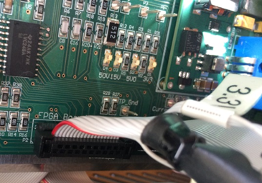

Figure 1. Special Test Cable orientation.

1. Switch on the mains and then switch on the 15 V power from the front plate.
2. Check **D2** (50 V) and **D10** (15 V) on the DC Supply Board. If **D11** lights up or **D10** flashes, it is indicative of a fault on the PDB.
   1. Fault-finding on the PDB:
      1. The IC **U2** and the 5 V module are possible failure points, as well as the regulators **U1** and **U3**.
   2. Fault-finding on the DC Supply board:
      1. Make sure you measure 3.3 V on the White Wire on the DC supply board (with 3.3 V on the STC).
      2. See that the 50 V (with 3.3 V applied on STC) and the 15 V works on the DC supply connector. This will toggle the switch and light up **D6** or **D5** (on DC supply board).
      3. **D5** indicates that the output is good and working.
      4. **D6** indicates there is a problem with the switch and that it should be replaced (on the Front Panel).
3. If all goes well **D1**, **D2** and **D3** on the Power Distribution Boardshould light up, as well as **D8**.
   * If **D1** is **OFF**, check the 3.3 V regulator **U1**.
   * If **D2** is **OFF**, check the 5 V DC-DC converter.
   * If **D3** is **OFF**, the 15 V line is faulty. Use the previous steps to debug.
   * **D8** is the fan controller, check **U3**.
4. Measure voltages **P1** (3.3±0.1 V), **P3** (5±0.2 V) and **P8** (15±0.2 V) on the PDB using a DMM.
5. Use 3.3 V from the desktop power supply to switch on the controller via the STC (**D4** should light up). Measure the 50 V on **P9**.
6. The fan should start up when you switch on 3.3 V over the STC. If the fan does not start up, you likely have an inrush current problem or **U3** is faulty.
7. Adjust the potentiometer **R35** to control the fan speed. You may turn the fan speed all the way down for the duration of the test procedure, but make sure to turn it back to full speed before closing the box up and installing!
8. If all is well, switch off the 3.3 V on the desktop power supply and then the 15 V from the front plate switch.

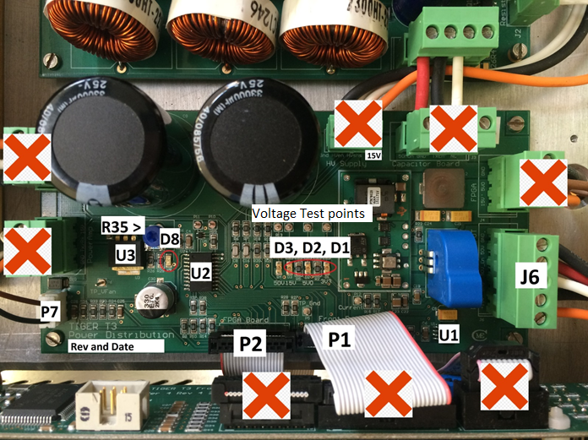

Figure 2. Important connections and components on the PDB.

**NOTE:**  
The older revisions on the PDB do not have the above setup exactly, they will use the 15 V (Orange) from the **J6** connector going to the HV supply board.

You can see the 15 V label on the HV Supply connector above, (on older ones this says 50 V instead). Make sure to do the above mod for older versions, but it is not needed for newer versions.

Newer versions have a 15 V pin here instead of the 50 V. Anything after Rev 1, 21 Sep 10 is considered “new”. To make sure just check if it has a 15 V output on the HV supply connector **J5** on the PDB.

# Conclusion

This concludes the work instructions for testing the Power Distribution board of a SuperDARN transceiver box. The next step in the procedure for Servicing a SuperDARN Transceiver is to test the Front Panel Board.